
PROJECT REPORT

Project Title: Warehouse Shelf Tracker
Submitted By: Samrata
SAP ID: 590021799
Course: B.Tech. Computer Science & Engineering
Course Code: CSEG1032
Submitted to: Rahul Prasad

INDEX
Sr. No. | Name | Pg. No.
1. | Abstract | 3
2. | Problem Definition | 4
3. | System Design | 6
4. | Implementation Details | 12
5. | Testing & Results | 17
6. | Conclusion & Future Work | 18
7. | Reference | 20
8. | Appendix | 21

ABSTRACT
This document describes the design and implementation of a Warehouse Shelf Tracker system. The application is a console-based utility developed in C, designed to manage the occupancy status of a fixed number of storage units (slots). The core functionality is achieved using a static integer array of size 10, where each index represents a storage slot.
The system supports binary tracking of inventory (occupied or empty) and provides essential features such as adding and removing items from specific slots, viewing the current shelf status, finding the first available empty slot, and globally clearing all stored inventory. The system ensures robust operation through boundary checks and validation against array limits and current slot occupancy.

PROBLEM DEFINITION

2.1. Goal
To create a simple, reliable console application that simulates the management of a fixed-size warehouse shelf, allowing a user to track the occupancy status of individual storage slots in real-time.

2.2. Functional Requirements
The system must satisfy the following user requirements:
- Add Item: Mark a specific, currently empty slot as occupied, provided the shelf is not full.
- Remove Item: Mark a specific, currently occupied slot as empty.
- View Status: Display the occupancy status (Empty/Occupied) for every slot, along with an overall summary (total items, total empty slots).
- Find Empty Slot: Identify and report the index of the first available empty slot, starting from index $0$.
- Count Empty Slots: Calculate and display the total number of empty slots remaining.
- Clear Shelf: Reset the status of all slots to empty.
- Exit: Terminate the application gracefully.

2.3. Constraints
- Fixed Capacity: The shelf must have a fixed capacity, defined by MAX_SLOTS (currently 10).
- Binary State: Each slot can only exist in one of two states: occupied or empty (1 or 0).
- Data Structure: The storage mechanism must be a standard C array.
- User Interface: The interface must be command-line (console) based.

SYSTEM DESIGN

Algorithm: Warehouse Shelf Tracker
Global Definitions
- Define Constant MAX_SLOTS = 10
Represents the total number of shelf slots available.
- Define Array shelf[MAX_SLOTS]
Stores 0 (empty) or 1 (occupied) for each slot.
- Define Integer count = 0
Stores the number of occupied slots.
Main Function (Control Loop)
Step 1: Start.
Step 2: Initialize variables
- Declare integer choice.
- Declare integer slot.
- Initialize array shelf with 0 (empty).
Step 3 (Start of Loop): Display the Main Menu:
- Add item to a slot
- Remove item from a slot
- View shelf status
- Find first empty slot
- Count empty slots
- Clear entire shelf
- Exit
Step 4: Ask user to enter choice. Read input into choice.
Step 5: Check user choice using Switch Case.
Case 1: Add Item
- Check if count == MAX_SLOTS
  - If TRUE: Display "Shelf Full" and Return.
- Ask user for slot number.
- Validate slot number (0–9).
- Check if slot is already occupied.
- If empty:
  - Set shelf[slot] = 1
  - Increment count
  - Display success message
- If count becomes 10, display "Shelf Full Warning".
- Return to Main Menu.

Case 2: Remove Item
- Ask user for slot number.
- Validate slot number (0–9).
- Check if slot is already empty:
  - If TRUE: Display "Already Empty".
- Else:
  - Set shelf[slot] = 0
  - Decrement count
  - Display "Item Removed".
- If count becomes 0, display "Shelf Empty".
- Return to Main Menu.

Case 3: View Shelf Status
- Print table-like slot status for all slots.
- Display total items stored.
- Display total empty slots.
- Display Shelf Status:
  - FULL (if count == 10)
  - EMPTY (if count == 0)
  - PARTIALLY FILLED otherwise
- Return.

Case 4: Find First Empty Slot
- Loop from i = 0 to 9
- If shelf[i] == 0:
  - Display that slot i is the first empty
  - Break
- If no slot found, display "Shelf Full".
- Return.

Case 5: Count Empty Slots
- Compute empty = MAX_SLOTS - count.
- Display number of empty slots.
- If empty == 0, display "Shelf Full".
- If empty == 10, display "Shelf Empty".
- Return.

Case 6: Clear Entire Shelf
- Loop from i = 0 to 9:
  - Set shelf[i] = 0
- Set count = 0
- Display "All slots cleared".
- Return.

Case 7: Exit
- Display “Exiting Program…”
- Stop the program.

Default Case
- Display “Invalid Choice”.
- Return to Main Menu.

IMPLEMENTATION DETAILS
1. Initializing Shelf System
A static integer array shelf[MAX_SLOTS] is used to store the status of 10 shelf slots, where
0 = empty and 1 = occupied.
A counter variable count tracks the total number of occupied slots.
Implemented using: arrays and variable initialization.
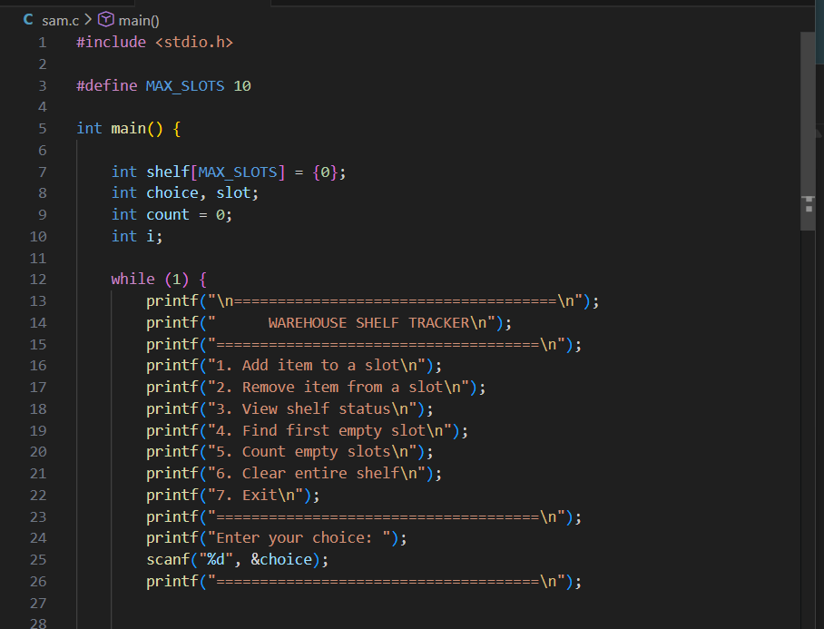

2. Adding an Item
The user enters a slot number.
The program checks if:
- the slot number is between 1–10
- the selected slot is empty
If valid, the program marks the slot as occupied and increments the count.
Implemented using: array indexing, validation, and conditionals.
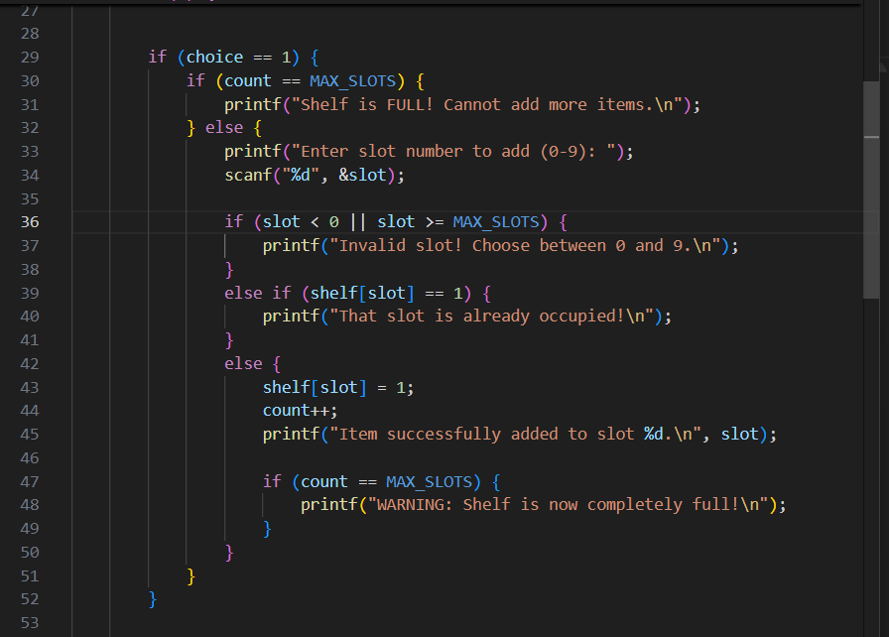

3. Removing an Item
The user chooses a slot to clear.
The program checks if:
- the slot number is valid
- the slot contains an item
If true, the slot is set to empty and the count decreases.
Implemented using: conditional checks and array updates.
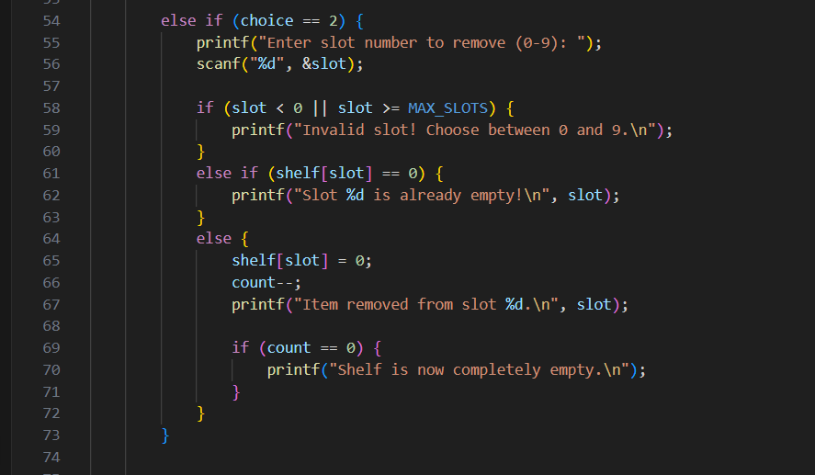

4. Viewing Shelf Status
Displays all 10 slots with their status (Empty/Occupied).
Loop is used to iterate through the array and print values.
Implemented using: for loops and formatted output.
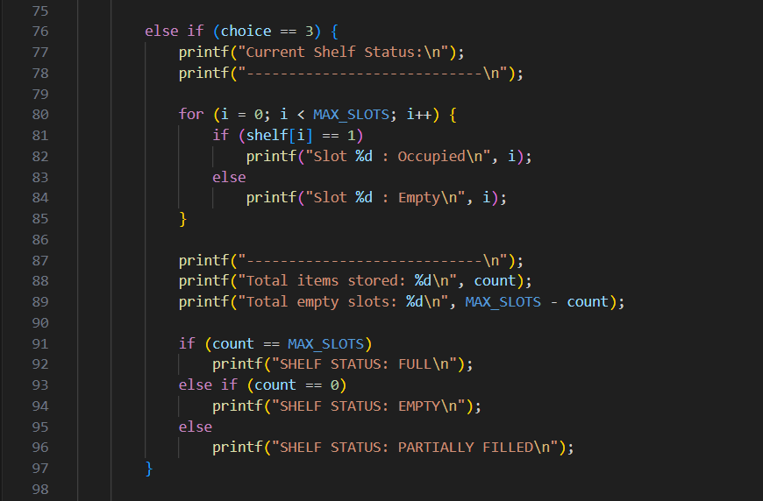

5. Viewing Total Items
Simply prints the value of the counter variable count, which stores the number of occupied slots.
Implemented using: integer counter tracking.
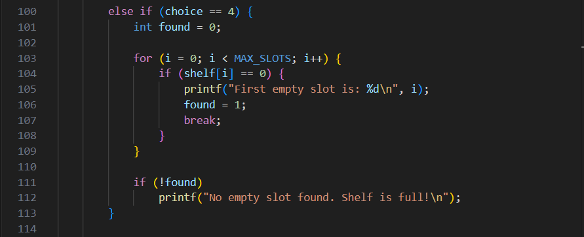

6. Resetting All Slots
This option clears all shelf slots by setting the entire array back to zero and resetting count to 0.
Implemented using: loops to reset array values.
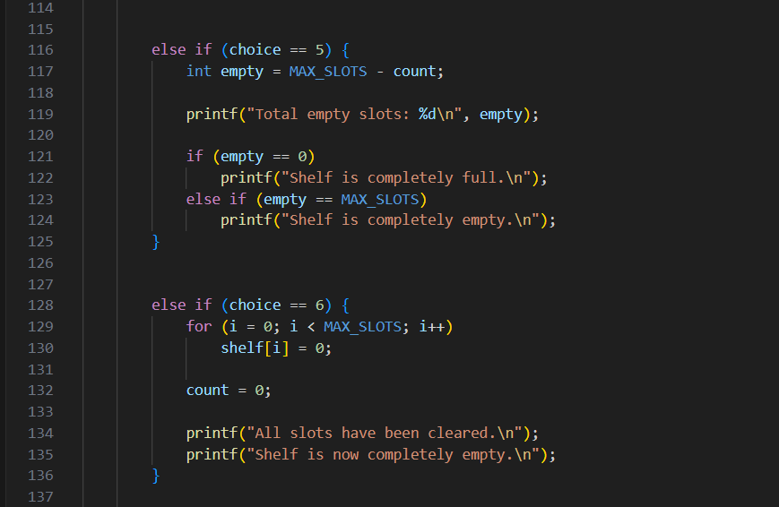

7. Exiting the Program
Selecting this option terminates the infinite loop and exits the program.
Implemented using: return statement from main().
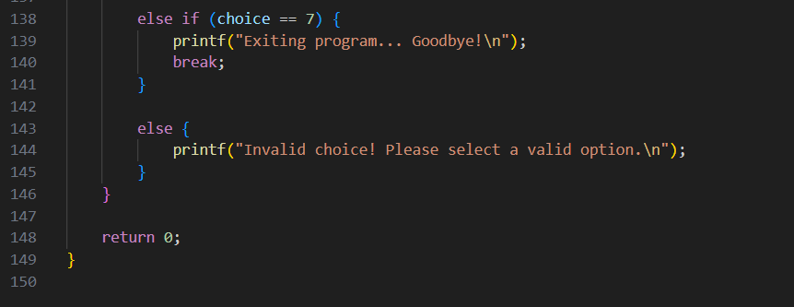

Testing and Results
The code was tested through various scenarios, inputting both valid and invalid entries.
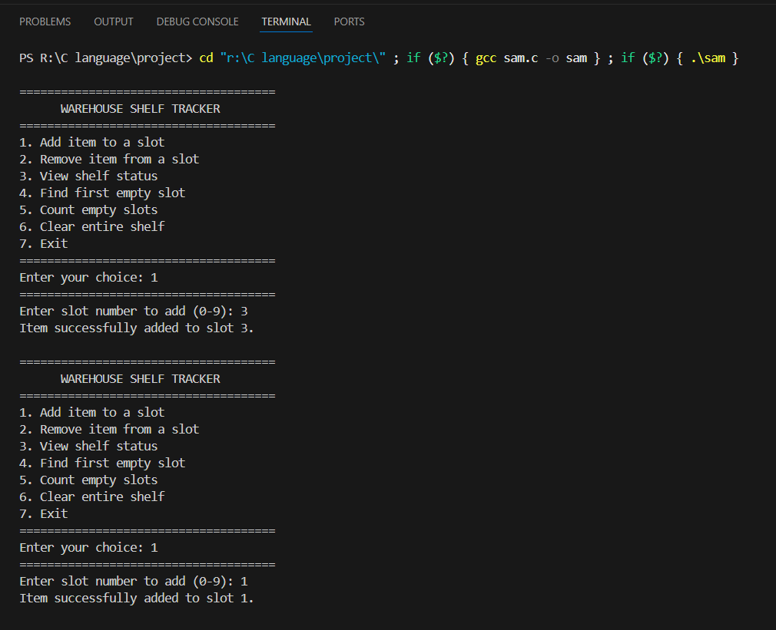
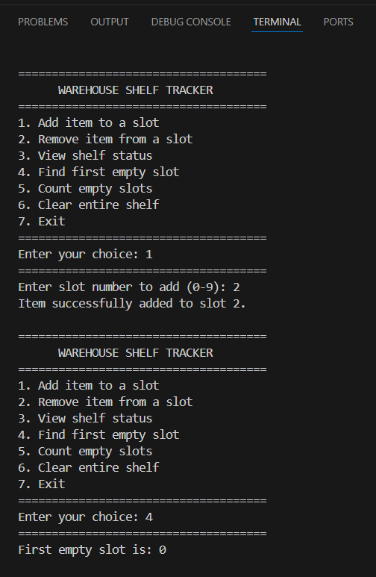

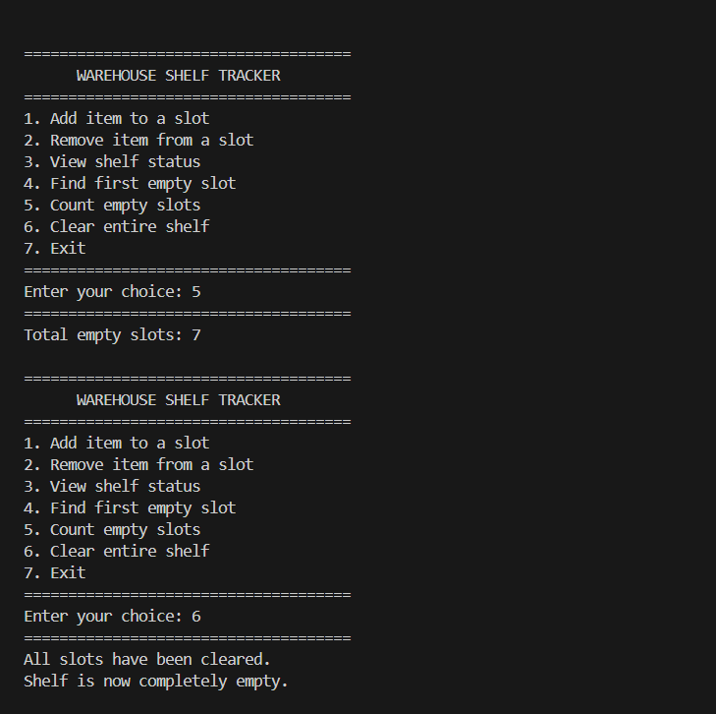
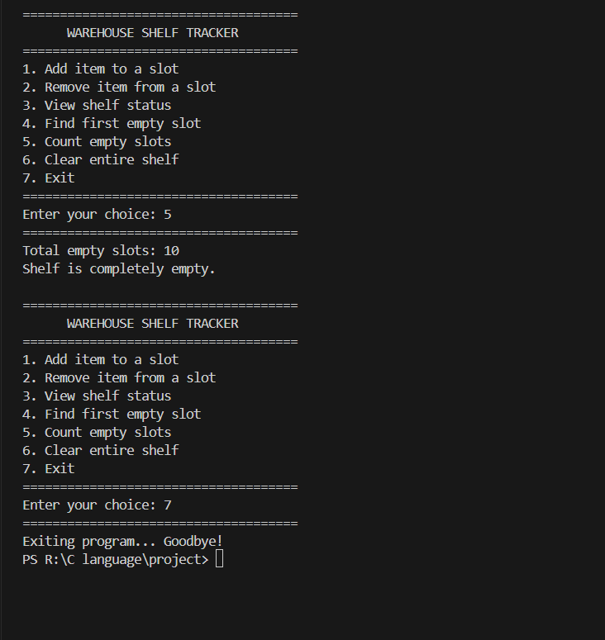

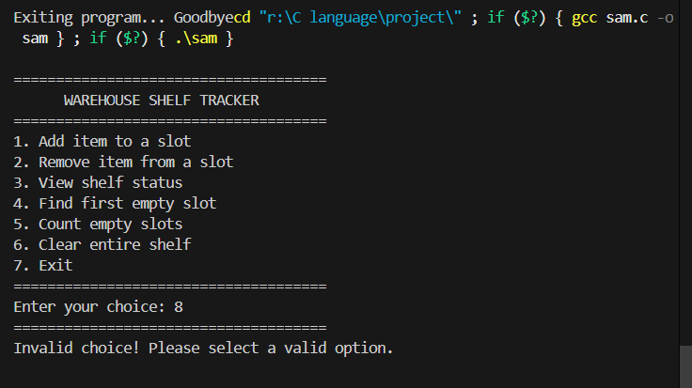

CONCLUSION & FUTURE WORK

Conclusion
The Warehouse Shelf Tracker successfully demonstrates how arrays and menu-driven programming can be used to manage storage slots efficiently. The program allows users to add, remove, search, count, and clear shelf items in real time. It ensures error-free operation through proper input validation and provides clear system status updates. This project strengthens understanding of conditional logic, loops, array manipulation, and user-interactive C applications.

Future Work
To improve and expand this project, the following enhancements can be implemented:
1. Dynamic Shelf Size
Allow users to choose the number of slots instead of using a fixed size (10).
2. Item Details
Store more information about each item (name, ID, weight, category) instead of only 0 and 1.
3. File Handling
Save shelf data to a file and load it on program start, ensuring data is not lost when the program exits.
4. Search Feature
Add functionality to search for specific items or item types.
5. GUI Version
Upgrade the program from a console interface to a graphical interface using libraries like GTK or a simple web-based frontend.
6. Multiple Shelves / Sections
Extend support for multiple racks, shelves, or warehouse zones.
7. Automatic Slot Allocation
Introduce algorithms to automatically find optimal slots based on size, weight, or item type.
8. Error Logging
Add logs to track incorrect inputs, removals, or system warnings.

REFERENCES
1. Mr. Rahul Prasad
2. Let us C by Yashwant Kanetkar
3. https://www.programiz.com/c-programming/online-compiler/
4. https://www.geeksforgeeks.org/c/c-programming-language/

APPENDIX
SOURCE CODE
#include <stdio.h>

#define MAX_SLOTS 10

int main() {

int shelf[MAX_SLOTS] = {0};
int choice, slot;
int count = 0;
int i;

while (1) {
printf("\n=====================================\n");
printf(" WAREHOUSE SHELF TRACKER\n");
printf("=====================================\n");
printf("1. Add item to a slot\n");
printf("2. Remove item from a slot\n");
printf("3. View shelf status\n");
printf("4. Find first empty slot\n");
printf("5. Count empty slots\n");
printf("6. Clear entire shelf\n");
printf("7. Exit\n");
printf("=====================================\n");
printf("Enter your choice: ");
scanf("%d", &choice);
printf("=====================================\n");

if (choice == 1) {
if (count == MAX_SLOTS) {
printf("Shelf is FULL! Cannot add more items.\n");
} else {
printf("Enter slot number to add (0-9): ");
scanf("%d", &slot);

if (slot < 0 || slot >= MAX_SLOTS) {
printf("Invalid slot! Choose between 0 and 9.\n");
}
else if (shelf[slot] == 1) {
printf("That slot is already occupied!\n");
}
else {
shelf[slot] = 1;
count++;
printf("Item successfully added to slot %d.\n", slot);

if (count == MAX_SLOTS) {
printf("WARNING: Shelf is now completely full!\n");
}
}
}
}

else if (choice == 2) {
printf("Enter slot number to remove (0-9): ");
scanf("%d", &slot);

if (slot < 0 || slot >= MAX_SLOTS) {
printf("Invalid slot! Choose between 0 and 9.\n");
}
else if (shelf[slot] == 0) {
printf("Slot %d is already empty!\n", slot);
}
else {
shelf[slot] = 0;
count--;
printf("Item removed from slot %d.\n", slot);

if (count == 0) {
printf("Shelf is now completely empty.\n");
}
}
}

else if (choice == 3) {
printf("Current Shelf Status:\n");
printf("----------------------------\n");

for (i = 0; i < MAX_SLOTS; i++) {
if (shelf[i] == 1)
printf("Slot %d : Occupied\n", i);
else
printf("Slot %d : Empty\n", i);
}

printf("----------------------------\n");
printf("Total items stored: %d\n", count);
printf("Total empty slots: %d\n", MAX_SLOTS - count);

if (count == MAX_SLOTS)
printf("SHELF STATUS: FULL\n");
else if (count == 0)
printf("SHELF STATUS: EMPTY\n");
else
printf("SHELF STATUS: PARTIALLY FILLED\n");
}

else if (choice == 4) {
int found = 0;

for (i = 0; i < MAX_SLOTS; i++) {
if (shelf[i] == 0) {
printf("First empty slot is: %d\n", i);
found = 1;
break;
}
}

if (!found)
printf("No empty slot found. Shelf is full!\n");
}

else if (choice == 5) {
int empty = MAX_SLOTS - count;

printf("Total empty slots: %d\n", empty);

if (empty == 0)
printf("Shelf is completely full.\n");
else if (empty == MAX_SLOTS)
printf("Shelf is completely empty.\n");
}

else if (choice == 6) {
for (i = 0; i < MAX_SLOTS; i++)
shelf[i] = 0;

count = 0;

printf("All slots have been cleared.\n");
printf("Shelf is now completely empty.\n");
}

else if (choice == 7) {
printf("Exiting program... Goodbye!\n");
break;
}

else {
printf("Invalid choice! Please select a valid option.\n");
}
}

return 0;
}

